THIS IS OUR PEACE:
VOICES ON NUCLEAR-NONPROLIFERATION

Preface
“This is our cry. This is our prayer. For building peace in this world.”
Children’s Peace Monument in Peace Memorial Park, Hiroshima

In August 1945, Nagasaki and Hiroshima were nearly decimated when atomic bombs detonated on the cities. While the act ended World War II, it left both cities and its people devastated in body and soul, with the after effects of radiation as a never-ending reminder.
Inspired by Sadako Sasaki, a young girl who contracted leukemia from radiation, a statue was erected in Hiroshima as a prayer for peace and in remembrance of the children who perished. Today, people can visit the statue and offer a paper crane as a sign of peace. Peace was Sadako Sasaki’s dying wish.
This book, a compilation of works by Iowa writers, shares words of peace, whether they’re in finding peace in the beauty of nature, the union of a community, or the love of family.
As you read these tales, ask yourself, how will you share your peace with the world?

Table of Contents
Samantha Ferm……………………………..…………....Before We Soar
Isabella Simonetti……………………………….…………Blessing Rana
Laura Crossett………………………………..………….On August Sixth
Dirk Marple…………………………………....….In Light of Hiroshima
Mallory Hellman………………………………………………......Haiku
Andrea Wilson…………………………………………….Iron Skeletons
Zoey Barnes………………………………...........................……untitled
Jessica Fletcher-Frye………………………..……The Peace that Comes
Erin Casey………………………………………………………Together
Ekaterina Filonova………………………………………….This Country
Martha Schut……………………………………………….prairie peace
Hunter Loushin……………………………………..…Bumblebee Tango
Frances Cannon………………………….conversations with night wings

Samantha Ferm
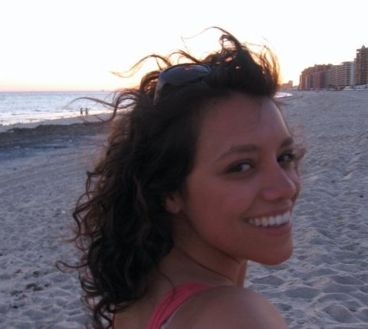

Originally from Arizona with long stops in Washington DC, Northern California, Ohio, and now Iowa City, Samantha is a lover of words, food + drink, connecting to good people, and general adventuring to any and all corners of this Earth.

Before We Soar

These years have scratched out
their quiet place between us;
Pale scars branch to wings.

Isabella Simonetti

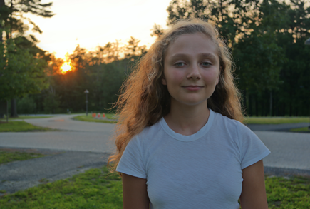

Isabella Simonetti is a young poet and non-fiction writer from New York City. She currently attends Avenues: The World Since in Chelsea, Manhattan where she is the editor-in chief of the school publication, The Highliner. Isabella has won seven Scholastic Art and Writing Awards for her work. She fell in love with writing after the early passing of her mother inspired her to share her story.

Blessing Rana

Oh Rana,
tell me
how are the sandy streets
and dried dates?
are notes of spice and lemon echoing through the air?
Oh Rana,
how is that bitter tongue you can’t bite?
you put yourself in so much danger
that I have to ask Allah to keep you safe.

Oh Rana,
if I were with you
we’d wrap ourselves under a blanket of the stars
and laugh about all we’ve lost
we’d travel to Morocco and see Mohammed
eat chicken tagine in the medinas
and drink mint tea from silver cups.
Oh Rana,
I hope the bombs don’t make you quiver
war cries are never as powerful as they seem
and I hope the dust in the air
doesn’t make you sneeze
but if it does I bless you
Oh Rana,
I bless you every time.

Laura Crossett

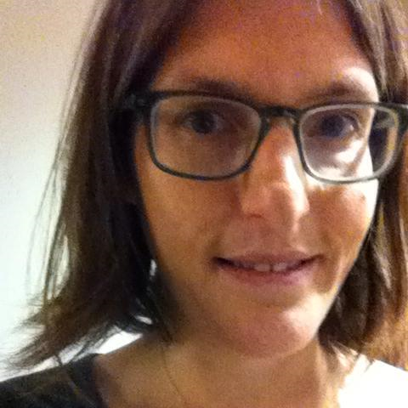

Laura Crossett is a librarian and the author of Night Sweats: An Unexpected Pregnancy. She lives in her hometown of Iowa City, Iowa with her son.

On August Sixth

I’m looking at a copy of my father’s army discharge papers from 1943. He was discharged honorably, “by reason of Disability, Section II, AR 615-360”—commonly called a Section 8, denoting someone mentally unfit for combat.
My father never fought in World War II, but like most men of his generation, he tried. He dropped out of college and enlisted (legend has it) by dint of memorizing the eye charts—he could read just enough of the top line of the two that were used that he could tell which one it was, so he memorized both, and that got him in. At least that is what I was always told, and perhaps it was true. But his discharge wasn’t for poor eyesight or flat feet. It was for mental illness. In 1943 they didn’t call it that, and certainly they did not treat it. They sent him home—the papers note he was “furnished Transportation in kind and attendants from Ft Riley, Kans. to 1487 E. 19th Street, Brooklyn, New York,” his home address. I imagine him showing up in civilian clothes on his parents’ doorstep, attended by two uniformed men, the same as the kind that show up to tell you your kid is dead, only these were there with a slightly different mission. Your kid isn’t dead, but he will be. Just not yet. Not for another 38 years, but not for lack of trying.
My father returned to Columbia after that and finished college, and then graduate school; he married, got teaching jobs, had two children, divorced, got married again, to my mother, and eventually they had me. On August 6, 1981, when I was five and a half, he killed himself. His sister told my mother he had tried before; she credited my mother with giving him another fourteen years of life.
I learned the date many years later, when I read his obituary in a box of condolence letters my mother kept, a box I still have not finished going through. By then, though, August 6 already had a different meaning for me: it was the day we dropped the first atom bomb on a human target. It was the day we bombed Hiroshima. It was the beginning of the end of the war my father didn’t fight in but tried to. It was one of the worst days in human history, before or since.

The bomb dropped on Hiroshima killed between 90,000 and 166,000 people. That our numbers are so inexact is a sign of what, I do not know—the times? the lack of understanding of the nature of radiation? a culture that counts only white deaths? Approximately half the people died the first day, killed by the blast and its destruction. The rest died in the days and weeks and months that followed, of burns and radiation and who knows what other effects of the bombs. When I was in sixth grade, we studied World War II. I read about the radiation and the burns. The boys at my table pored over the pictures of mushroom clouds, and I felt sick—sick and knowing what they had done, sicker still at seeing them seem to relish the photos, as if the formations in the sky had no effect on the people below.
I do not know when I began to conflate the events of August 6, and it seems unfair and disrespectful of me to do so. How can you compare the death of one to the deaths of tens of thousands? How can you compare a self-inflicted harm to one done by the government in the name of its people? You can’t, of course. But they arrive each year in my head, double tragedies, and perhaps the connection is this: that I long that day and each day for peace—for a peace among nations, and among people, but also for a peace within ourselves.
My grandmother once told me my father had been found walking around base talking about how he just wanted to go to Walden Pond. Perhaps this is what made the army doctors realize that war would break him, or perhaps it made them realize, as I believe, that he was already broken. The army was wise enough not to send my father to war, and I am grateful to them for that. Some days I wonder why they could not have been wise enough not to go to war themselves. For that, I have no answer.

Dirk Marple

Born in Iowa City in 1986, Dirk has attended the University of Iowa, Luther College, and various schools abroad, earning his Bachelors of Art from Luther in 2009 with a degree in mathematics. After graduating he has turned his attention to poetry and creative writing, taught ESL in South Korea, and is currently enrolled in an online nonfiction course hosted by the University of Iowa’s International Writing Program.

In Light of Hiroshima
I
each angel that jumped from
the bridge fell down through
cloud cover to wash
ashore as granules
of sand—photons of light.
*exodus*, or *ethic purging*, most
said nothing, went about
the morning accustomed
to the light.
II
those who remembered, thereby,
carried with them
the weight of light
in their being.

III
taking time each morning
to fold clothes and to
place the dishes into
dry stacks and fold a single
paper bird.
IV
having seen the light
went collecting brass buttons
along the river each morning
for decades, the only remnants
of dead school children
dumped into the water
with the other bodies,
from their school uniforms.
having seen the light
went collecting along
the river each morning
for decades the brass
buttons of uniforms
the only remnants
of dead school children
dumped into the water
with the other bodies.
V
along the road of shattered
houses were neatly set piles
of folded clothes
for children.
VI
walking the waterside
building cairns and small towers
out of pocket stones—
what they carried with them.

Mallory Hellman

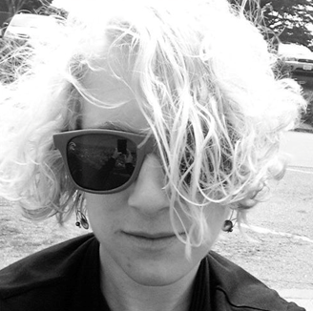

Mallory Hellman is a graduate of the Iowa Writers’ Workshop. She currently serves as the Director of the Iowa Youth Writing Project which brings writing and literary skills to
school-aged children.

Haiku

Imagine the day
when we teach our men to love
before they can shoot.

Andrea Wilson

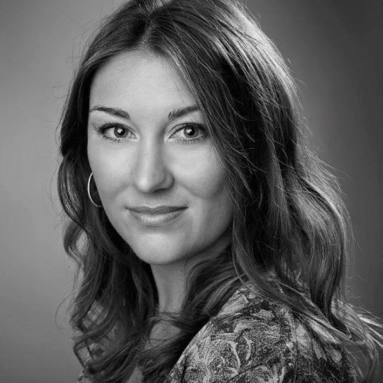

Andrea believes that the path to a better world is paved with stories, our words, the bricks of our shared humanity.
She founded the Iowa Writers’ House as one step forward.

Iron Skeletons

In Hiroshima, I stood,
charred
skeletons of iron
haunting the
skies,
towering
above
rubble of humanity.
How can the image
of victory
be painted
In pain.

Zoey Barnes

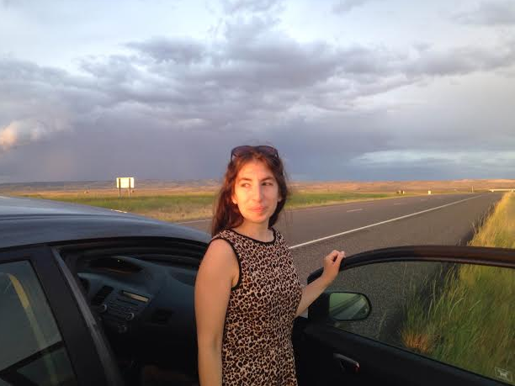

Zoey Barnes is a writer and bookseller living in Iowa City. She holds an MFA in Nonfiction from the University of Montana. She grew up in Santa Fe, New Mexico.

untitled

on the radio,
Iran, then, Hiroshima,
hear, what we have built

Jessica Fletcher-Frye

A recent graduate from the University of Iowa, Jessica received her Bachelors in English. Previously, she interned for the Iowa City UNESCO City of Literature and became submersed in Iowa City's literary community. An avid reader, amateur chef, and music lover, she is currently a social media Intern at the Iowa Writers’ House.

The Peace that Comes

The peace that comes through the comfort of prayer
The peace that comes when looking out onto the ocean’s horizon
The peace that comes after climbing to the mountain’s highest peak
The peace that comes as you turn the last page of a beloved novel
The peace that comes by being surrounded by a loving embrace
The peace that comes as you stare into the eyes of a newborn child
The peace that comes when a community rallies together to stand for a cause
The peace that comes after a storm of hardships passes through
The peace that comes as you stand in the sun’s warmth on an afternoon day
The peace that comes when you fall asleep next to the one you love
The peace that comes through the encouragement of others
The peace that comes when you take a moment to be washed in humility
The peace that comes in the form of helping hands and open minds
The peace that comes from the world and finds a home in my heart

Erin Casey

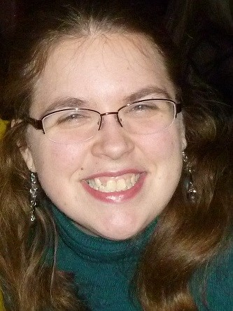

Erin graduated from Cornell College in 2009 and attended the Denver Publishing Institute. While working at Pearson, she also holds an intern position at the Iowa Writers’ House. She is an active writer and has recently completed the rough draft of a medieval fantasy trilogy that she has been writing for the past four and a half years.

Together

I used to play outside, as a child,
until bullets bellowed across the street.
The couch became my shield, my protection,
from the monsters in masks.

Until bullets bellowed across the street,
my world was surrounded by a bubble,
hiding me from the monsters in masks,
making me feel safe in school, at church.

My world was encompassed by a bubble
until students died at the hands of classmates,
making me feel afraid in school, at church.
A theater, a mall, a chapel; nowhere was safe.

Until students died at the hands of gunmen,
I didn’t realize that there was evil in the world.
A theater, a mall, a chapel were safe.
Oh, but now I know so much better.

I couldn’t see the evil that was in the world,
but neither did I realize how kindness grew.
Now, I know so much better
when I see a community pull together in hope.

I did not realize the kindness of strangers
until food was given to the homeless.
I watch a community pull together with humility
when people are in need of shelter or friendship.

Food is given to the homeless
and our nation unites as one against tyranny.
When people are in need of shelter and friendship,
volunteers work to erect safe habitats.

Our nation unites as one against tyranny
and pleads for peace across the world.
Volunteers work to bare our flag
and remind us we can only have peace, together.

Ekaterina Filonova

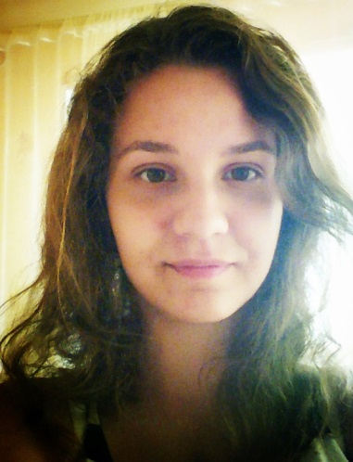

Ekaterina lives in Dzerzhinsk, Russia, and is a sophomore at Nizhny Novgorod State Linguistic University. In 2013 she took part in the University of Iowa’s International Writing Program “Between the Lines” during which she wrote this poem. It was included into the anthology.

This Country

To this country planes do not fly – they run (like a soaked through dog runs home – with its fur ironed to the body, ears pressed, eyes screwed up – forward and forward, drawing the smell of the master`s hands in). In this country the air is packed into two kinds of bottles – the first – with ice – for the inside of the buildings, the second – with hot humming bees – for the streets. Here rabbits stand like soldiers – ears-guns look up, the triggers are nearly pressed by the fingers, touch them – they shoot.
Small towns are all in little holes.
Here streets are talking to feet with tattoos-quotations on their brick faces. The roads, worn out by the dancing cowboy`s boots, spread under the wheels. And the whole town is breathing with words, with poetry and stories.
But my tongue is toddling with the crutches step by step and the words it carries are heavy and awkward. They can`t go out and fall back into the throat. The pile of them - head over heels - is spinning in my breast like in the washing machine.
I need to do my verbal laundry.
I`m standing in the center of the hut made of glass and wood that seems to be deserted.
But in the country where the wind smells marshmallows over the campfire, and the shadows of the trees dress women`s legs in stockings, there are no deserted spots. In this country every corner is full of music.
I hear it, standing in the hut. And the center of it is being filled with the sun.

Martha Schut
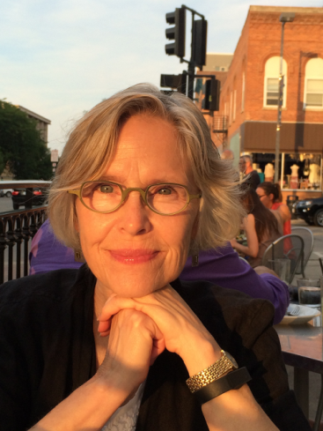

Martha is a poet, social activist and student of the Italian language, recently retired psychotherapist. Earlier, she was a financial analyst for General Electric, chorus singer in off-off Broadway and light opera in NYC. She is living part of the year in Umbria and the rest in Iowa City.

prairie peace

purple coneflower
queen anne’s lace, weary susan
damsel flies nearby

Hunter Loushin
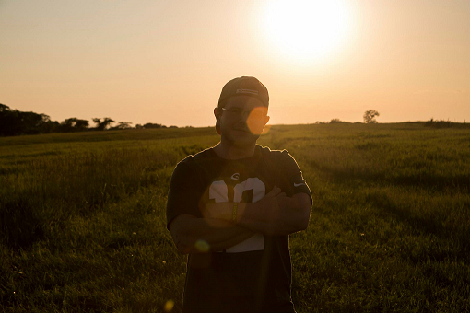

Hunter Loushin is currently a senior at the University of Iowa as an English major who looks forward to completing the undergraduate creative writing track for poetry, as well as pursuing a cinema minor. Born and raised in Cedar Rapids, Iowa he attributes his poetic growth to the loving support of his family, friends, and teachers.

Bumblebee Tango

Glades by the crick
with endless blades of various
shades of green and shapes of leaves.
Buzzing and beeping, mellow
minute creeping from an uncountable
amount of winged consciousness.
The golden hour flows west
up the water, through the tree branches as if bowing for the encore;
applause with blinks.

There, taller, in plain view
curdling flowers that open
for a few, one at a time
who gently touch on unconscious cue.
Three dimensional contact
above: ants and spiders, dandelions
and not so dandy sprucing, like
buses with ailerons, around
on bulbous legs; shot
like paint from a Pollock brush
but slower.

Frances Cannon

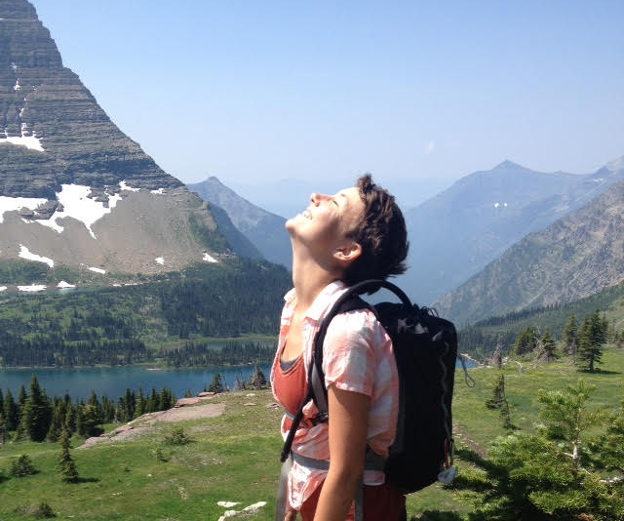

Frances Cannon studied poetry and printmaking at the University of Vermont and has been backpacking, cooking, and pursuing adventure with a fury. She is currently pursuing her MFA in nonfiction and book arts at the University of Iowa.

conversations with night wings

The giant silkworm moth
of the midwest, with frilled horns
and legs like pipe cleaners,
waits patiently on the doorknob
for my return home from
thunder-lit rambles. His cousin,
a smaller and more humble
white moth, clings to my foot
during a moonlit walk. Undisturbed
by a faraway owl hoot
and the more intimate puff-warning
of a doe in my garden, the moth follows me to bed and resettles
on my pillow. Peace is in the breath
of this moth’s feet as I dream.

About The
Iowa Writers’ House

The Iowa Writers’ House is a community writing organization that welcomes all writers into its inspiring, creative, and supportive environment. We believe that sharing the stories within us is the path to our best selves and a better world.
The mission of the Iowa Writers’ House (IWH) is to extend the Iowa literary legacy to all people and strengthen community among writers, editors, readers, audiences, and all those who believe that writing connects us, leads us to new perspectives, and ultimately unites us in our shared human experiences.
www.iowawritershouse.org

